Project Planning Phase
Project Planning Template (Product Backlog, Sprint Planning, Stories, Story points)

Date | 18 June 2026
Team ID
Project Name | House Rent
Maximum Marks | 5 Marks

Product Backlog, Sprint Schedule, and Estimation (4 Marks)

Sprint | Functional Requirement (Epic) | User Story Number | User Story / Task | Story Points | Priority | Team Members
Sprint-1 | Authentication | USN-1 | As a user, I can register an account with role selection (Owner/Renter). | 4 | High | Team
Sprint-1 | Authentication | USN-2 | As a user, I can log in securely using my credentials. | 4 | High | Team
Sprint-1 | Authorization | USN-3 | As a user, I can access pages based on my role permissions. | 5 | High | Team
Sprint-2 | Property Management | USN-4 | As an owner, I can add a rental property with details and images. | 7 | High | Team
Sprint-2 | Property Management | USN-5 | As an owner, I can view and delete my listed properties. | 6 | High | Team
Sprint-3 | Property Search | USN-6 | As a renter, I can browse available rental properties. | 4 | High | Team
Sprint-3 | Property Search | USN-7 | As a renter, I can search properties based on preferences. | 4 | High | Team
Sprint-4 | Visit Booking | USN-8 | As a renter, I can schedule a property visit by selecting date and time. | 8 | High | Team
Sprint-4 | Booking Management | USN-9 | As an owner, I can approve or reject visit requests. | 6 | High | Team
Sprint-4 | Negotiation | USN-10 | As a renter, I can negotiate the rental amount with the owner. | 7 | Medium | Team
Sprint-5 | Administration | USN-11 | As an admin, I can manage users, properties, and bookings. | 8 | High | Team
Sprint-5 | Project Enhancement | USN-12 | As a developer, I can remove the sale feature and make the platform rent-only. | 5 | Medium | Team
Sprint-5 | Branding & Documentation | USN-13 | As a developer, I can complete project branding and documentation. | 5 | Medium | Team
Total Story Points = 73

Project Tracker, Velocity & Burndown Chart: (4 Marks)
Sprint | Total Story Points | Duration | Sprint Start Date | Sprint End Date (Planned) | Story Points Completed (as on Planned End Date) | Sprint Release Date (Actual)
Sprint-1 | 17 | 3 Days | Day 1 | Day 3 | 17 | Day 3
Sprint-2 | 13 | 2 Days | Day 4 | Day 5 | 13 | Day 5
Sprint-3 | 8 | 1 Day | Day 5 | Day 5 | 8 | Day 5
Sprint-4 | 21 | 3 Days | Day 6 | Day 8 | 21 | Day 8
Sprint-5 | 14 | 1 Day | Day 9 | Day 9 | 14 | Day 9
Total | 73 | 9 Days | - | - | 73 | -
Velocity:
Imagine we have a 10-day sprint duration, and the velocity of the team is 20 (points per sprint). Let’s calculate the team’s average velocity (AV) per iteration unit (story points per day)

AV=73/9=8.11

Burndown Chart:
A burn down chart is a graphical representation of work left to do versus time. It is often used in agile software development methodologies such as Scrum. However, burn down charts can be applied to any project containing measurable progress over time.
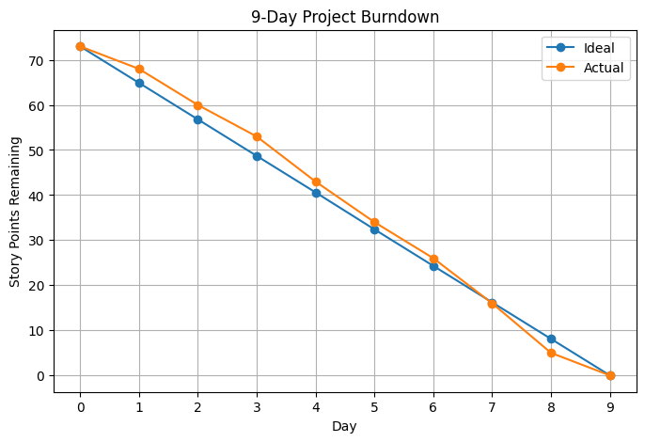

https://www.visual-paradigm.com/scrum/scrum-burndown-chart/
https://www.atlassian.com/agile/tutorials/burndown-charts

Reference:
https://www.atlassian.com/agile/project-management
https://www.atlassian.com/agile/tutorials/how-to-do-scrum-with-jira-software
https://www.atlassian.com/agile/tutorials/epics
https://www.atlassian.com/agile/tutorials/sprints
https://www.atlassian.com/agile/project-management/estimation
https://www.atlassian.com/agile/tutorials/burndown-charts

